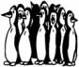
2007 ARCTIC MILE Results

Open Women Division

- Emily Mazzaferri 6:28
- Jane Looby 6:36
- Bri McCauley 6:59
- Morgan Reede 7:00
- Karen Vottero 7:51
- Jamie Blankenship 8:01
- Jill Black 8:01
- Beth Sovacool 12:54

Men’s’ Division <18

1. Caleb Withers 5:13
2. Christian Jones 5:23
3. Derek Curry 5:24
4. Kyle Esber 5:28
5. Derek Hartman 5:34
6. Richard Schmidt 5:58
7. Brian Blankenship 6:01
8. Robbie Rhodes 6:15
9. Jake Hill 6:17
10. Kevin Collmar 6:18
11. Ian Klein 6:28
12. Alex Skelley 6:24
13. Andrew Miller 6:24
14. Owen Riley 7:26

Men’s’ Division >18

1. Dave Marchionie 4:48
2. Chris Sovacool 5:02
3. Sean Kelley 5:03
4. Sam Cirelli 5:32
5. Eric Prescott 6:00
6. Adam Booth 6:16
7. Shaun Kimbrough 6:23
8. Marco Wootor 6:43
9. Andy Black 6:50
10. Ryan Jones 8:33
11. Brady Winkler 8:45
12. John Winkler 8:45
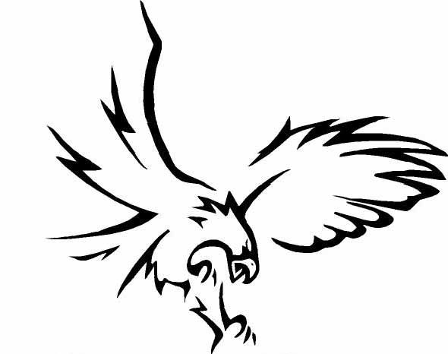
13. Mahmood Soorma 10:35

